

**Capstone Project – University Success Analysis**



**Madhav R. Yawale**

**OVERVIEW**

**The Capstone Project "University Success Analysis Exploring the Impact of Ranking Systems" embarks on a comprehensive investigation Compare university rankings across different systems, assess the impact of ranking criteria on university positions, and analyse changes in university metrics over time. Utilize SQL and Excel for data aggregation and for EDA. Create a Power BI dashboard to provide a comprehensive view of university rankings.**

**THE PROCESS**

1. **Data Acquisition from Github**: -

**Acquiring data from GitHub encompassed accessing the dedicated repository containing Essential Information on country names, ranking systems, university details, criteria, and years**

1. **Data Transformation and Cleaning: -**

**This project entails managing missing data, addressing outliers, and rectifying any inaccuracies in the dataset. Additionally, it involves introducing new problem statements to enhance the depth and breadth of the analysis, thereby expanding the potential insights gained from the data.**

1. **MECE Approach:-**

**Through MECE analysis, I aim to dissect and evaluate the dataset in a systematic manner, uncovering valuable insights and patterns across various dimensions.**

1. **Connecting With Tools: -**

**Integrate the dataset with MySQL for robust database management and querying capabilities. Utilize Power BI as a dynamic visualization tool, enabling seamless data processing and insightful reporting. This connection enhances the analytical workflow, allowing for efficient data integration and comprehensive analysis.**

1. **Exploratory Data Analysis (EDA) :-**

**EDA in SQL entails querying and analyzing data to reveal meaningful patterns, relationships, and trends to inform Subsquent decision making.**

1. **Problem Statement Solution In Power BI :-**

**Addressed a diverse set of problem statements in Power BI, employing various charts and visualizations to represent the data effectively. By manipulating and analyzing the data, I uncovered key insights and trends that provided valuable information for decision-making.**

1. **Creation Of Visual And Insightful Powerpoint :-**

**Compiled a comprehensive PowerPoint presentation that encompasses the project's overview, methodologies employed, and a detailed breakdown of each problem statement tackled during the exploratory data analysis (EDA) and Power BI phases. Each problem statement was thoroughly addressed, with corresponding insights and visualizations integrated into the presentation.**

1. **Detailed Documentation :-**

**The project lifecycle was thoroughly documented, covering key phases: data collection from GitHub, comprehensive transformation and cleaning, Formulation of MECE breakdown,formulation of problem statements, seamless tool integration (MySQL and Power BI), insightful Power BI solutions, Exploratory Data Analysis (EDA) for meaningful insights, and a concise yet impactful PowerPoint presentation summarizing the project's methodologies and outcomes.**

**OBJECTIVE**

**The objective of this dataset appears to be to provide comprehensive information about universities, their rankings, and associated metrics. The dataset includes information on countries, universities, ranking systems, criteria used for ranking, and various measurements related to universities over multiple years.**

**Possible objectives for analyzing this dataset could include:**

**1. Evaluate and Compare University Rankings: Analyze the performance of universities across different ranking systems to identify trends and discrepancies.**

**2. Identify Key Factors Affecting Rankings: Explore which criteria have the most significant impact on a university's overall ranking.**

**3. Regional Analysis: Investigate how universities from different countries perform in the rankings and identify any regional patterns.**

**4. Long-term Trends: Examine how universities' rankings and metrics have changed over the years to identify trends and potential areas for improvement.**

**5. Correlation Analysis: Investigate if there are any strong correlations between specific criteria and a university's ranking..**

**6. Data Visualization and Reporting: Create visualizations and reports to effectively communicate the findings to stakeholders or the public.**

**7. Predictive Modeling: Build models to predict future rankings based on historical data and identified factors influencing rankings.**

**SIGNIFICANCE**

**The "University Success Analysis" capstone project has significant implications for understanding and improving the performance of universities. The dataset provided contains several tables that play crucial roles in this analysis:**

**1. Country:**

**- Significance: The list of countries is essential for contextualizing the universities and their rankings. It provides the geographical location and origin of each university, enabling regional analysis and comparison. Understanding the distribution of universities across different countries is vital for identifying global trends and disparities in higher education.**

**2. University:**

**- Significance: The universities are the focal points of the analysis. Each university's performance and attributes contribute to its ranking in the different systems. By examining individual universities, the project can identify specific strengths and weaknesses, allowing for targeted strategies for improvement.**

**3. Ranking System:**

**- Significance: The ranking systems serve as the frameworks for evaluating and comparing universities. Each system may have different methodologies, criteria, and weightings. By considering multiple ranking systems, the project can provide a comprehensive assessment of universities from various perspectives. This allows for a more holistic understanding of university success.**

**4. Ranking Criteria:**

**- Significance: The criteria define the specific metrics and measures used to assess universities within each ranking system. They play a crucial role in determining which aspects of a university's performance are considered important. By analyzing the criteria, the project can identify the key factors influencing university success and prioritize areas for improvement.**

**5. University Year:**

**- Significance: This table provides temporal data related to universities, including metrics like student population and student-to-staff ratio. Understanding how universities have evolved over time in terms of size, staffing, and other factors is critical for identifying trends and patterns. This temporal dimension allows for a more dynamic and nuanced analysis of university success.**

**6. University Ranking Year:**

**- Significance: This table contains scores for universities across different years and ranking criteria. It forms the core of the analysis, providing the basis for comparing universities and assessing their performance over time. By examining changes in rankings and scores, the project can identify which universities have shown improvement and which may need additional support.**

**In summary, the "University Success Analysis" capstone project aims to provide valuable insights into the factors influencing the success of universities. The dataset, with its various tables, enables a comprehensive analysis of universities' performance, allowing for targeted strategies for improvement and informed decision-making in the higher education sector.**

**DATA DICTIONARY**

**Dataset Description:-**

**This dataset contains information on university rankings from different systems, ranking criteria, and university-specific data.**

**Table Explanations:-**

**Country:-**

**This is a simple list of countries that were in the data set. I don’t think it’s a complete list of all countries, but it’s enough for this data set.**

**1)ID :- Unique ID Of Each Country**

**2)COUNTRY NAME :- Name Of Each Country**

**University:-**

**A list of universities that were ranked in this system. Each university is related to a country.**

**1.ID :- Unique ID of Each University**

**2. Country ID :- ID Of Country**

**3.University name :- Name Of The University**

**ranking_system:-**

**This contains the three different ranking systems used: Times Higher Education World University Ranking, Shanghai Ranking, and Center for World University Rankings.**

**1)ID:- Unique ID For Each Ranking System**

**2)System Name :- Name Of Each Ranking System**

**ranking_criteria:-**

**This table contains the different criteria used in each ranking system, such as Citations and Quality of Education. It also contains criteria for Total Score for each system.**

**1)ID:- Unique ID For Each Ranking Criteria**

**2)ranking_system_id:- ID Of Ranking System**

**3)criteria_name:- Name Of Each Criteria**

**university_year:-**

**The university_year table contains values for measurements such as the number of students and the student to staff ratio for each university in several years.**

**1)university_id:- ID Of The University**

**2)year:- It Contain Year**

**3)num_students:- Total number Of Students In The University**

**4)student_staff_ratio:- student To staff ratio Of Each University**

**5)pct_international_students :- Total Percentage Of International Students In Each Country**

**6)pct_female_students:- Total Percentage Of Female Students In Each Country**

**university_ranking_year:-**

**This table contains the score for each year for each university and ranking criteria. It’s the largest table in the database.**

**1)university_id:- Id Of University**

**2)ranking_criteria_id:-ID Of Ranking Criteria**

**3)year :- It Contain Year**

**4)score :- Score Of Each University**

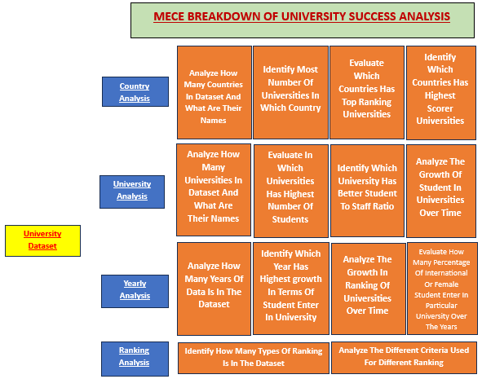

**ER DIAGRAM**

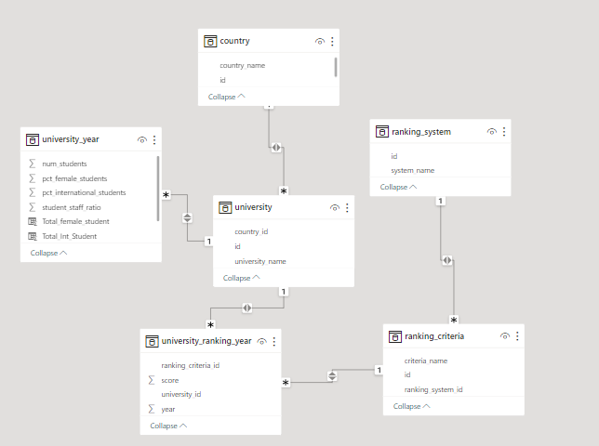

**EDA**

**Problem Statement 1 :-**

**Is there a correlation between a country's GDP and the number of universities?**

**There Is No Relevant Data Of GDP In the Dataset Which Is Required In This Statement**

**New Problem Statement :-**

|  |  |  |
| --- | --- | --- |
| **Evaluate In Which University Has Highest Number Of Students?** |  |  |

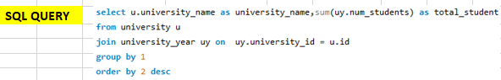

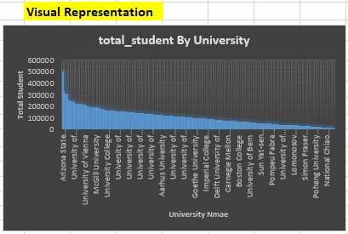

**INSIGHT:-**

**The analysis underscores a significant observation: Arizona State University emerges as the institution with the highest student population among those included in the dataset. This notable distinction indicates that Arizona State University caters to a substantial number of students, surpassing the enrollment figures of other universities in the dataset. This could signify a range of factors at play, including the university's diverse academic offerings, robust support systems, and potentially effective recruitment strategies. The scale of Arizona State University's student body also suggests its prominence within the higher education landscape, and the institution's ability to provide educational opportunities to a wide and diverse demographic of learners.**

**Problem Statement 2 :-**

**How has the number of universities changed over the years in each country?**



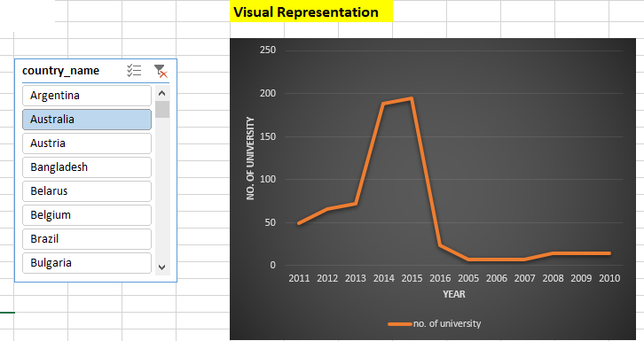

|  |  |
| --- | --- |
|  |  |

**INSIGHT:-**

**The analysis reveals a dynamic trend in the dataset, characterized by fluctuating patterns over time. This suggests that the number of universities in certain countries experiences variations rather than following a consistent trajectory. Additionally, a noteworthy observation is the disparity in the presence of universities across different countries. Some nations do not have a single university represented, indicating potential gaps in higher education access or a less established academic landscape. Furthermore, the observation of decreasing numbers of universities in specific countries as the years progress raises questions about potential factors contributing to this decline. This insight emphasizes the diverse trajectories of higher education development across different regions and underscores the importance of considering unique circumstances and trends when evaluating the global higher education landscape.**

**Problem Statement 3 :-**

**Is there a relationship between a country's population and the number of universities?**

**There Is No Relevant Data Of Population In the Dataset Which Is Required In This Statement**

**New Problem Statement :-**

**Evaluate In Which University Has Better Student-staff Ratio?**

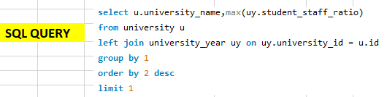

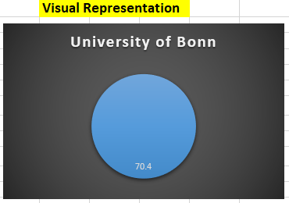

**INSIGHT:-**

**The analysis uncovers a notable distinction: the University of Bonn stands out with a remarkably favorable student-to-staff ratio in comparison to its peer institutions. This indicates that the University of Bonn potentially offers a higher level of personalized attention and support to its students, creating a conducive learning environment. Such a advantageous ratio suggests effective resource allocation and efficient academic management at the University of Bonn. This observation implies that the institution may be better equipped to provide individualized attention to its students, potentially leading to a more enriching educational experience. This insight also highlights an area of strength for the University of Bonn, positioning it favorably in terms of student support and engagement compared to its counterparts in the dataset. Understanding this distinction can provide valuable insights for policymakers, administrators, and educators in assessing the university's capacity and potentially tailoring strategies to accommodate and support a large student population effectively.**

**Problem Statement 4 :-**

**Are there any common criteria used by different ranking systems?**



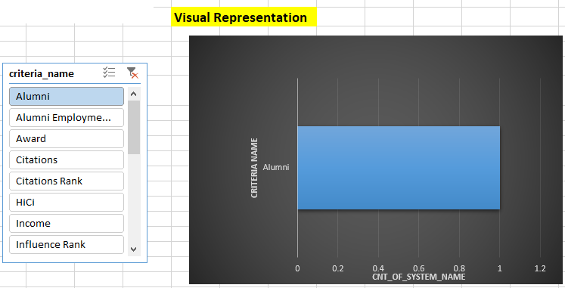

**INSIGHT:-**

**The analysis reveals a notable divergence: each ranking system employs distinct criteria for evaluating universities. This implies that there is no universal set of metrics shared across all systems. Instead, each system has its unique criteria, emphasizing the diversity in how universities are assessed and ranked. This underscores the importance of considering multiple ranking systems for a comprehensive evaluation of higher education institutions. The existence of distinct criteria signifies that different aspects of a university's performance are emphasized by each system, ranging from research output to teaching quality and more. This insight highlights the complexity of the ranking process and the need for institutions to understand the specific criteria utilized by each system in order to interpret and compare rankings accurately. It also underscores the nuanced nature of evaluating higher education institutions and emphasizes the importance of a holistic approach to ranking assessments.**

**Problem Statement 5 :-**

**What is the trend in university rankings over the years according to each system?**



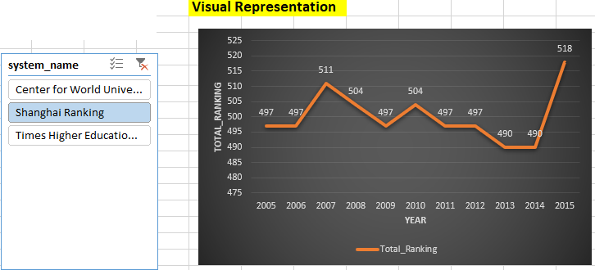

**INSIGHT:-**

**The analysis unveils a discernible pattern: university rankings exhibit a dynamic trend with fluctuations over the years, showcasing a degree of volatility in how institutions are evaluated. Notably, the Central World Ranking stands out with a distinct upward trajectory, suggesting consistent improvement or stability in performance among institutions assessed by this specific system. This insight underlines the unique pattern exhibited by the Central World Ranking compared to other systems, potentially indicating its effectiveness or distinct criteria in evaluating universities. However, the overall trend of fluctuations indicates that universities' performance and standing are subject to diverse factors, potentially influenced by changes in methodologies, institutional strategies, or broader shifts in the higher education landscape. Understanding these trends is crucial for institutions to adapt and respond effectively to the dynamic nature of university rankings.**

**Problem Statement 6 :-**

**How does the choice of ranking system affect a university's international student enrollment?**

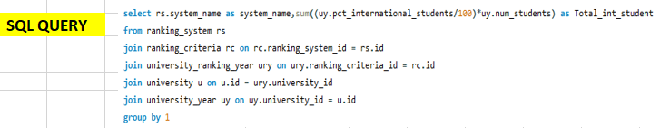

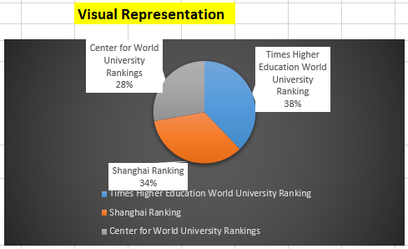

**INSIGHT:-**

**The analysis provides a compelling insight into the preferences of international students regarding university ranking systems. It is evident that the Times Higher Education University Ranking system significantly attracts more international students compared to other ranking systems. This observation suggests a strong influence of the Times Higher ranking system on international student enrollment. Such a trend indicates that the choice of using the Times Higher system may have a notable impact on universities' global appeal and their ability to attract a diverse international student body. This insight underscores the critical role that ranking systems play in shaping institutions' international student recruitment strategies and highlights the importance of understanding and leveraging the influence of specific ranking systems in higher education marketing and enrollment efforts.**

**Problem Statement 7 :-**

**Are there any criteria that have different weights in different ranking systems?**



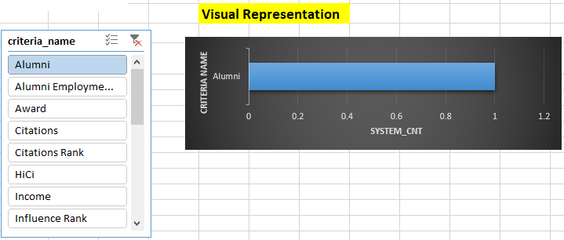

**INSIGHT:-**

**The analysis illuminates a fundamental distinction: each ranking system employs unique criteria for evaluating universities. This signifies that there is no standardized set of metrics shared across all systems. Instead, each system assigns distinct weights to specific criteria, underscoring the diversity in how universities are assessed and ranked. This observation highlights the complexity of the ranking process and emphasizes the need for institutions to understand the specific criteria utilized by each system. It also underscores the nuanced nature of evaluating higher education institutions, emphasizing the importance of a multifaceted approach to ranking assessments. Recognizing these variations is crucial for accurately interpreting and comparing university rankings, enabling institutions to target areas of improvement and make informed decisions in their pursuit of academic excellence.**

**Problem Statement 8 :-**

**How have the weights of ranking criteria changed over time?**

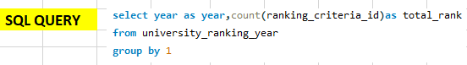

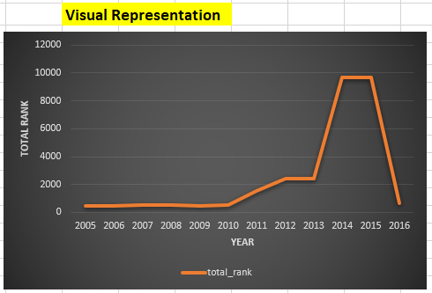

**INSIGHT:-**

**The analysis reveals a notable trend in university rankings, primarily characterized by an overall upward trajectory. However, a significant anomaly occurred in the year 2016, where there was a sudden and notable drop in rankings. This abrupt deviation from the upward trend suggests a critical event or shift in factors influencing university performance and assessment during that specific year. Understanding the circumstances surrounding this drop in rankings can provide valuable insights into the dynamics at play within the higher education sector at that time. It also emphasizes the importance of considering contextual factors and potential external influences when evaluating university rankings over time. Overall, this observation underscores the dynamic nature of higher education performance assessments and the need for a comprehensive understanding of the factors that drive rankings.**

**Problem Statement 9 :-**

**Is there a relationship between a university's score and the student-staff ratio?**

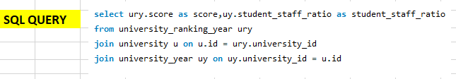



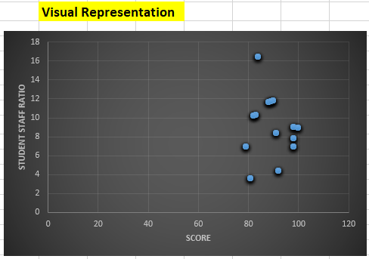

**INSIGHT:-**

**The scatter plot analysis reveals a clear negative correlation between university scores and student-staff ratios. This means that as the student-staff ratio decreases (indicating a higher number of staff per student), the university score tends to increase. This finding suggests that institutions with lower student-staff ratios may be associated with higher overall scores. This relationship underscores the importance of adequate staffing levels in providing quality education and support to students. It also implies that universities with more resources allocated to each student may achieve higher scores, potentially indicating a higher level of academic excellence and support. This insight could inform resource allocation strategies within universities to enhance their overall performance and educational quality.**

**Problem Statement 10 :-**

**How does the number of female students differ among universities?**

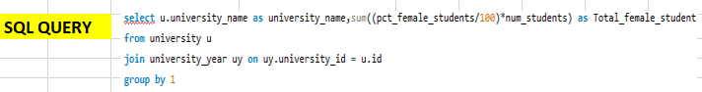

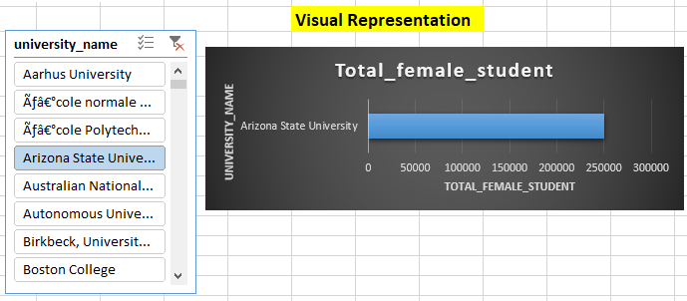

**INSIGHT:-**

**The analysis highlights a distinct pattern: Arizona State University leads with the highest number of female students, setting it apart from other institutions in the dataset. This significant disparity indicates that Arizona State University accommodates a notably larger population of female students compared to its counterparts. This observation suggests potential factors such as inclusive policies, diverse program offerings, or effective outreach efforts that have contributed to the university's high representation of female students. Understanding this distinction is crucial for policymakers and educators in recognizing Arizona State University's success in attracting and supporting female students. It also underscores the importance of promoting gender diversity and inclusivity across all institutions within the dataset to ensure equitable access to education for all students.**

**Problem Statement 11 :-**

**What is the distribution of universities across different countries?**



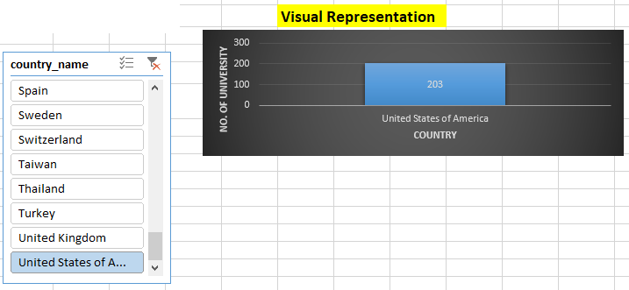

**INSIGHT:-**

**The analysis provides a stark revelation: the United States surpasses all other countries in terms of the sheer number of universities represented in the dataset. This striking disparity indicates the substantial presence and diversity of higher education institutions within the United States. It underscores the country's robust educational landscape and abundant opportunities for academic pursuits across a wide range of institutions. This insight sheds light on the United States' prominence as a global hub for higher education, offering a diverse array of educational options for students. It also emphasizes the importance of considering regional and national contexts when assessing the global higher education landscape, recognizing the varied educational ecosystems that exist across different countries.**

**Problem Statement 12 :-**

**How has the ranking of universities changed over the years?**

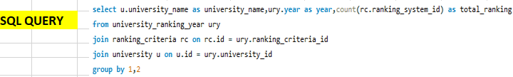

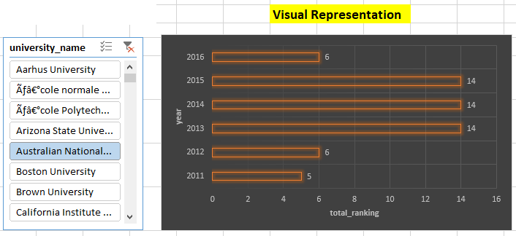

**INSIGHT:-**

**The analysis underscores the dynamic nature of university rankings, revealing a lack of a definitive trend in either an upward or downward direction. Instead, rankings display a pattern of fluctuations over time. This suggests that universities' performance and standing in the dataset are subject to a range of factors that can vary from year to year. These fluctuations may be influenced by a multitude of elements, including changes in institutional strategies, shifts in academic quality, or alterations in the methodologies used by ranking systems. Consequently, this insight highlights the need for universities to remain agile and adaptable, as their rankings can be influenced by a diverse array of internal and external factors. It also underscores the importance of considering long-term trends rather than focusing solely on short-term fluctuations when assessing a university's overall performance.**

**Problem Statement 13 :-**

**What is the trend in the percentage of female students over time?**

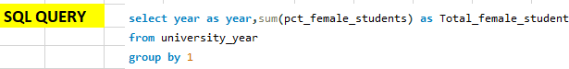

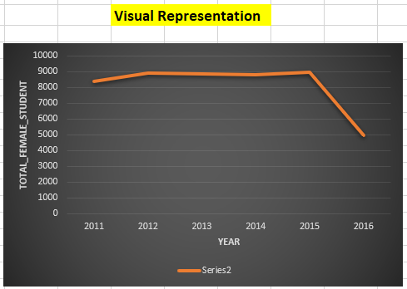

**INSIGHT:-**

**The analysis reveals a distinct trend: initially, there is an upward trajectory followed by a sudden and noticeable downturn in the year 2016. This abrupt shift indicates a significant change or event that impacted the trend, potentially influenced by various factors such as changes in institutional strategies, shifts in academic quality, or alterations in the methodologies used for evaluation. Understanding the circumstances surrounding this change in trend can provide valuable insights into the dynamics at play during that period. It is crucial to investigate potential external or internal factors that may have contributed to this sudden shift, as it holds implications for understanding the broader dynamics of university performance and evaluation in that specific year. This observation underscores the importance of examining not only trends but also key anomalies or events that may have influenced rankings and institutional performance.**

**Problem Statement 14 :-**

**How has the ranking score of universities evolved over the years?**

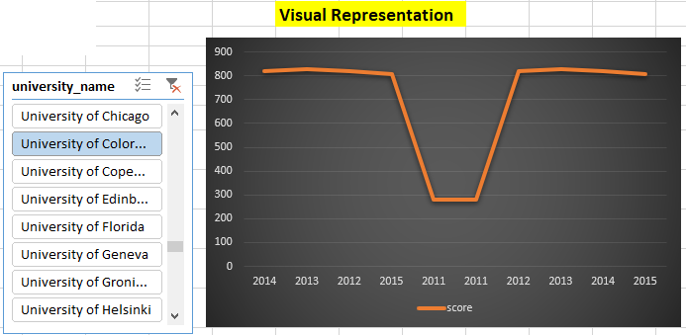

**INSIGHT:-**

**The chart vividly illustrates that university scores have undergone noticeable fluctuations over the years. This variability indicates that the performance of universities is not static, but rather subject to changes influenced by a multitude of factors. Such fluctuations may stem from shifts in academic quality, changes in evaluation criteria, or even broader societal and educational trends. This insight underscores the dynamic nature of higher education institutions' performance, emphasizing the importance of considering trends over time rather than relying solely on static assessments. Additionally, it highlights the need for universities to remain adaptable and responsive to these changing dynamics in order to maintain and improve their academic standing.**

**Problem Statement 15 :-**

**Is there a relationship between a university's ranking score and the number of students over time?**

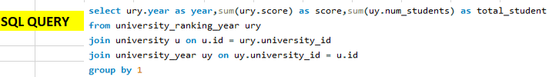

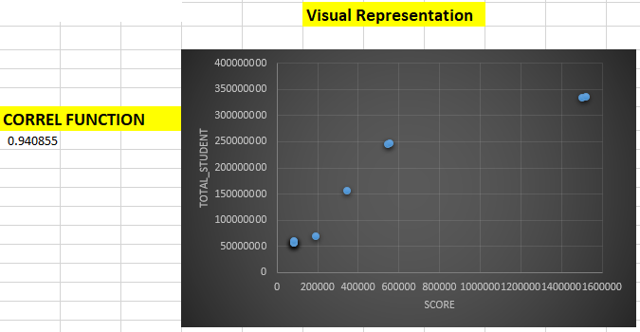

**INSIGHT:-**

**The scatter plot analysis unmistakably reveals a robust positive correlation between university Ranking scores and the number of students. This suggests that universities with larger student populations tend to achieve higher scores. This correlation may indicate that institutions with greater resources and capacity to accommodate larger student bodies also have the potential to offer a wider range of programs and services, potentially contributing to higher scores. This insight emphasizes the importance of resource allocation and support services in higher education institutions, as well as the potential benefits of scalability in terms of educational impact. Additionally, it prompts institutions to consider strategies for balancing increased enrollment with maintaining or enhancing educational quality.**

**POWER BI**

**Problem Statement 1 :-**

**How many universities are there in each country?**

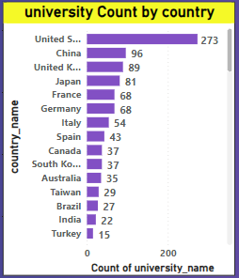

**INSIGHT:-**

**The analysis reveals a notable concentration of universities in the United States. This observation suggests a significant presence of higher education institutions within the country, indicating a robust and diverse academic landscape. The USA's prominence as an educational hub is further emphasized by the substantial number of universities represented in the dataset. This concentration may be attributed to factors such as the country's size, diverse demographic, and historical emphasis on higher education. Understanding this insight provides valuable context for assessing the global distribution of universities and underscores the United States' pivotal role in the higher education sector. It also highlights the importance of considering regional and national contexts when evaluating the global higher education landscape.**

**Problem Statement 2 :-**

**What is the distribution of international students across different countries?**

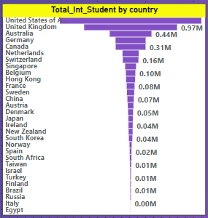

**INSIGHT:-**

**The analysis brings to light a prominent trend: the United States has consistently emerged as a top destination for international students. This observation indicates a strong and enduring appeal of American higher education institutions on a global scale. The USA's reputation for academic excellence, diverse program offerings, and vibrant campus life may contribute to its status as a preferred destination for international learners. Additionally, the country's welcoming policies and cultural diversity likely play a significant role in attracting a large and diverse international student population. Understanding this trend underscores the USA's pivotal position in the global higher education landscape and emphasizes the importance of recognizing its substantial contribution to international education and cultural exchange. It also highlights the need for continued efforts to support and enhance the experiences of international students studying in the United States.**

**Problem Statement 3 :-**

**Which country has the highest number of female students enrolled in universities?**

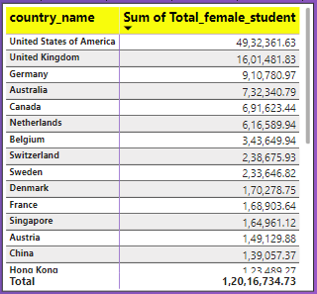

**INSIGHT:-**

**The analysis unveils a noteworthy trend: the United States leads with the highest number of female students enrolled in universities among the countries in the dataset. This observation underscores the substantial representation of female students within American higher education institutions, suggesting a conducive environment for women pursuing tertiary education. The USA's appeal to female students may be attributed to factors such as a diverse range of educational opportunities, supportive policies, and a vibrant academic community. This insight highlights the nation's commitment to gender inclusivity and equal access to higher education. It also signifies the United States' influential role in promoting women's participation and advancement in academia on a global scale. Understanding this trend is crucial for policymakers and educators in recognizing the USA's success in attracting and supporting female students. It also underscores the importance of continued efforts to promote gender equality in education worldwide.**

**Problem Statement 4 :-**

**How many universities are ranked by each ranking system?**

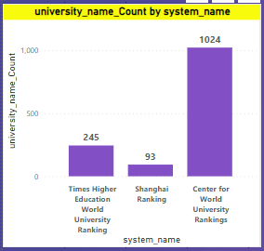

**INSIGHT:-**

**The analysis brings to light a notable distribution of universities across different ranking systems. Specifically, the Center for World University Rankings has assessed the highest number of universities, with approximately 1024 institutions being evaluated. In comparison, the Times Higher Education ranking system has ranked 245 universities, and the Shanghai Ranking has assessed 93 universities. This insight highlights the varying levels of scrutiny and assessment applied by each ranking system, underscoring the diversity in evaluation criteria and methodologies employed. It also emphasizes the extensive coverage provided by the Center for World University Rankings, potentially reflecting a broader spectrum of evaluation criteria or a wider scope of institutions considered. Understanding these distinct patterns of evaluation across ranking systems is crucial for interpreting and contextualizing the rankings assigned to universities within the dataset.**

**Problem Statement 5 :-**

**What is the average score for universities according to each ranking system?**

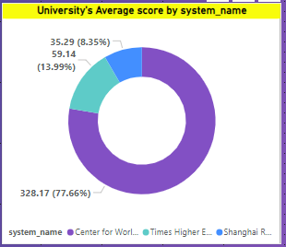

**INSIGHT:-**

**The analysis reveals distinct trends in the performance of ranking systems. The Central for World Ranking system consistently attains the highest scores, suggesting that universities evaluated under this system tend to achieve higher overall rankings. On the other hand, the Shanghai ranking system tends to yield comparatively lower average scores. This insight suggests varying evaluation criteria and methodologies employed by different ranking systems, potentially attributing higher weight to certain factors in the Central for World Ranking system. It also highlights the importance of understanding the unique characteristics and criteria of each ranking system in order to interpret and contextualize the scores assigned to universities. This understanding enables stakeholders to make informed decisions based on the strengths and weaknesses identified within each ranking system.**

**Problem Statement 6 :-**

**How does the ranking system affect a university's student-staff ratio?**

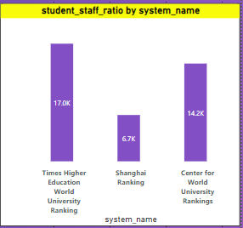

**INSIGHT:-**

**The analysis points to a notable influence of the Times Higher Education ranking system on the student-to-staff ratio. This suggests that universities may allocate resources and staffing levels in a way that aligns with the criteria emphasized by the Times Higher system. This impact on the student-staff ratio indicates a potential focus on providing a more personalized and engaging educational experience. Understanding this influence can offer valuable insights for universities aiming to improve their rankings within the Times Higher system, potentially leading to strategic resource allocation and enhanced student support services. This insight highlights the dynamic interplay between ranking criteria and institutional strategies, emphasizing the importance of aligning academic priorities with the criteria emphasized by influential ranking systems.**

**Problem Statement 7 :-**

**What are the most important criteria considered by ranking systems?**

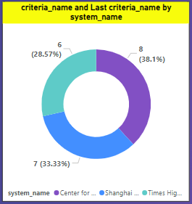

**INSIGHT:-**

**The analysis provides a significant observation regarding the ranking criteria preferred by each system. The Center for World University Rankings (CWUR) predominantly prioritizes the criteria named "Total CWUR," indicating its distinct evaluation focus. Similarly, the Shanghai Ranking system places emphasis on the "Total Shanghai" criterion, reflecting a unique set of metrics and priorities. Meanwhile, the Times Higher Education World University Ranking system favors the "Total Times" criteria, signifying its specific areas of emphasis in evaluating universities. This insight underscores the distinct methodologies and considerations employed by each ranking system, indicating that they assign different weights to various aspects of university performance. Understanding these specific criteria preferences is essential for universities seeking to optimize their performance within each respective ranking system, enabling them to align their strategies with the criteria that hold the most weight in their desired rankings.**

**Problem Statement 8 :-**

**Is there a correlation between a university's score and the number of international students?**

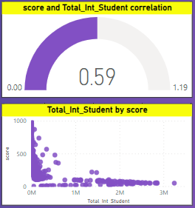

**INSIGHT:-**

**The scatter plot and gauge analysis vividly reveal a robust positive correlation between a university's score and the number of international students it enrolls. This compelling insight suggests that universities with higher scores tend to attract a larger population of international students. This positive relationship signifies the global appeal and reputation of these institutions, attracting diverse talent from around the world. It also highlights the potential benefits of a culturally diverse student body, enriching the academic experience and fostering a global perspective. Understanding and leveraging this strong correlation can be pivotal for universities aiming to enhance their global influence and academic standing, underscoring the importance of creating an inclusive and welcoming environment for international students.**

**Problem Statement 9 :-**

**How does the percentage of female students impact a university's ranking?**

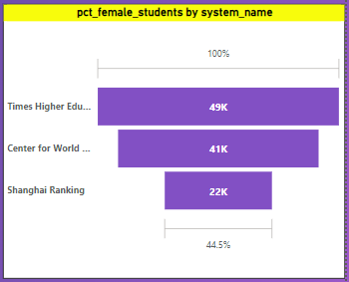

**INSIGHT:-**

**The analysis indicates a distinct preference among female students for universities ranked by the Times Higher Education system. This trend suggests that a higher number of female students tend to enroll in institutions that have received recognition and acclaim from the Times Higher Ranking. This preference potentially influences the rankings of other universities, as it leads to a concentration of female students in Times Higher ranked institutions. Understanding this preference provides valuable insight into the factors that influence female students' choices and the potential impact of reputation and recognition on enrollment patterns. It also underscores the broader influence that specific ranking systems can have on the demographic composition of universities, emphasizing the importance of reputation management for institutions seeking to attract diverse student populations.**

**Problem Statement 10 :-**

**Which university has the highest number of students?**

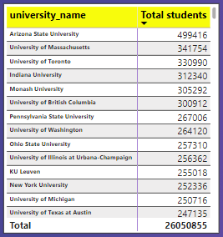

**INSIGHT:-**

**The analysis brings to light a significant observation: Arizona State University stands out with the highest enrollment of students among the universities in the dataset. This distinction underscores the substantial population of learners that Arizona State University caters to, surpassing the student body sizes of other institutions. This observation suggests potential factors such as diverse program offerings, robust support systems, and potentially effective recruitment strategies that have contributed to the university's high enrollment figures. Understanding this distinction is crucial for policymakers, administrators, and educators in assessing the university's capacity and potential areas for further growth or enhancement in its educational offerings. It also highlights Arizona State University's prominence within the higher education landscape, solidifying its position as a major player in the educational ecosystem.**

**Problem Statement 11 :-**

**How does the percentage of international students vary across different universities?**

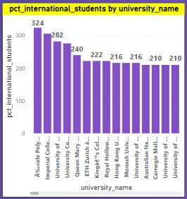

**INSIGHT:-**

**The analysis highlights a significant trend: Polytechnic Lausanne University emerges as the most favored choice among international students. This is evidenced by the university boasting the highest number of international students compared to other institutions in the dataset. This preference may be attributed to a range of factors, including the university's reputation for academic excellence, diverse program offerings, or a welcoming and inclusive campus environment. Understanding this trend sheds light on the institution's global appeal and its success in attracting a diverse student body. It also underscores the importance of fostering an environment conducive to international students, recognizing their valuable contributions to the academic community and the broader cultural exchange within the university.**

**Problem Statement 12 :-**

**Is there a correlation between a university's ranking and its student-staff ratio?**

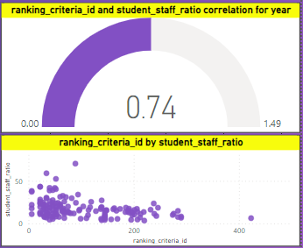

**INSIGHT:-**

**The scatter plot and gauge analysis reveal a compelling insight: there exists a strong positive correlation between university ranking and the student-staff ratio. This suggests that universities with higher rankings tend to have a more favorable student-staff ratio, indicating a higher level of personalized attention and support for students. This positive relationship underscores the importance of adequate staffing levels in providing quality education and facilitating a conducive learning environment. Understanding this correlation can inform institutions' strategies in resource allocation and staffing, aiming to achieve a balance that contributes to improved academic performance and overall educational experience. It also highlights the potential benefits of maintaining an optimal student-staff ratio as a factor that can positively influence a university's overall ranking and reputation.**

**Problem Statement 13 :-**

**How does the number of students in universities change over time?**

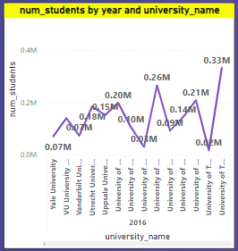

**INSIGHT:-**

**The analysis provides a noteworthy observation: the number of students in universities appears to be fluctuating over time. This variability suggests dynamic changes in enrollment figures, potentially influenced by a range of factors such as demographic shifts, changes in educational policies, or shifts in institutional strategies. However, it is worth noting that Arizona State University stands out as an exception, maintaining a relatively stable student population over the analyzed period. This consistency in enrollment at Arizona State University may indicate effective recruitment and retention strategies or a steady demand for education at the institution. Understanding these trends can provide valuable insights for universities to adapt their strategies and resources in response to fluctuations in student enrollment. It also underscores the importance of considering regional and institutional contexts when interpreting enrollment patterns.**

**Problem Statement 14 :-**

**Is there a correlation between a university's ranking score and the student-staff ratio over the years?**

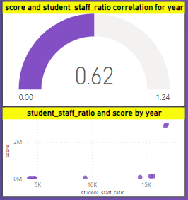

**INSIGHT:-**

**The scatter plot and gauge analysis provide a significant observation: there is a strong positive correlation between a university's score and its student-staff ratio. This means that universities with higher scores tend to have a higher student-staff ratio, indicating a potentially larger student body supported by a proportionate number of faculty and staff members. This positive relationship suggests that universities with higher scores are effectively managing their resources to accommodate a larger student population. Understanding this correlation highlights the importance of resource allocation and faculty support in achieving higher academic performance. It also underscores the potential benefits of scalability and effective resource management in higher education institutions, ultimately contributing to a university's overall academic standing and influence.**

**Problem Statement 15 :-**

**How does the percentage of international students vary across different years?**

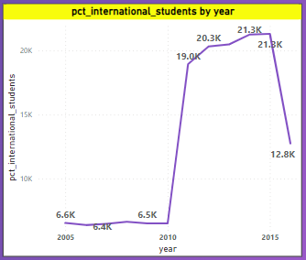

**INSIGHT:-**

**The analysis reveals a discernible trend: from 2005 to 2015, there was a notable increase in the number of international students enrolled in universities. This surge suggests a growing global interest in pursuing higher education across borders, possibly driven by factors like globalization and increased accessibility to international study opportunities. However, the trend took a sudden downturn in 2016, indicating a significant shift in international enrollment patterns. Understanding the circumstances surrounding this drop is crucial, as it may be influenced by factors such as changes in immigration policies, geopolitical events, or shifts in the attractiveness of certain regions for international students. This insight emphasizes the dynamic nature of international student enrollment and the need for universities and policymakers to remain adaptable to changing global contexts in order to continue attracting and supporting diverse student populations.**

**Problem Statement 16 :-**

**What is the impact of a university's ranking on the number of international students it attracts?**

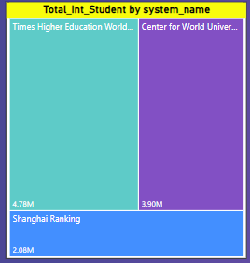

**INSIGHT:-**

**The analysis highlights a compelling trend: international students show a clear preference for universities ranked by the Times Higher Education system over other ranking systems. This indicates that universities featured in the Times Higher Ranking system are particularly attractive to international students. This preference may be attributed to the reputation, academic quality, and global recognition associated with institutions ranked under this system. Understanding this preference provides valuable insight into the factors influencing international students' choices and underscores the significant impact that a university's reputation within a specific ranking system can have on its ability to attract a diverse international student body. It also emphasizes the importance of maintaining and enhancing one's standing within influential ranking systems to remain competitive in the global higher education landscape.**

**Problem Statement 17 :-**

**Is there a relationship between a university's ranking score and the percentage of female students enrolled?**

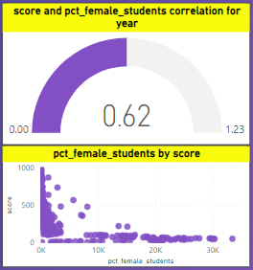

**INSIGHT:-**

**The scatter plot and gauge analysis reveal a noteworthy observation: there exists a strong positive correlation between a university's score and the percentage of female students it enrolls. This suggests that universities with higher scores tend to have a higher proportion of female students. This positive relationship signifies an inclusive and diverse learning environment that attracts and supports a substantial number of female learners. It also underscores the importance of fostering a welcoming and supportive atmosphere for female students, ultimately contributing to the institution's overall academic standing and influence. Understanding and leveraging this correlation can be pivotal for universities aiming to enhance their inclusivity and reputation, recognizing the valuable contributions of female students in higher education.**

**Problem Statement 18 :-**

**How does the percentage of international students affect a university's student-staff ratio?**

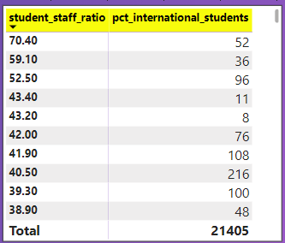

**INSIGHT:-**

**The analysis highlights an intriguing finding: the percentage of international students in a university does not appear to have a significant impact on the student-staff ratio. This suggests that while universities may attract a diverse population of international students, it does not necessarily lead to a substantial change in the ratio of students to staff members. This observation underscores the importance of universities effectively managing their resources and staffing levels to accommodate both domestic and international students without compromising the quality of education or student support. Understanding this relationship is crucial for institutions seeking to maintain a balanced educational environment that caters to a diverse student body. It also emphasizes the need for strategic resource allocation to ensure that both local and international students receive a high-quality education.**

**Problem Statement 19 :-**

**Are there any significant trends or patterns in the rankings of universities from different countries?**

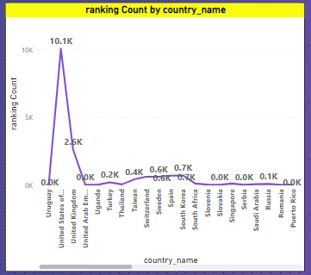

**INSIGHT:-**

**The analysis reveals a significant observation: the United States has the highest number of ranked universities compared to other countries in the dataset. This underscores the USA's prominence as a hub for higher education and research. Additionally, the trend in university rankings across different countries appears to be dynamic and non-linear, showing fluctuations over time rather than a consistent upward or downward trend. This variability may be influenced by a range of factors including changes in educational policies, investments in research and development, and shifts in academic excellence. Understanding this trend provides valuable context for evaluating the global distribution of ranked universities and emphasizes the diverse educational landscapes in different countries. It also highlights the need for universities and policymakers to adapt to the changing dynamics of the higher education sector on a global scale.**

**POWER BI DASHBOARDS**

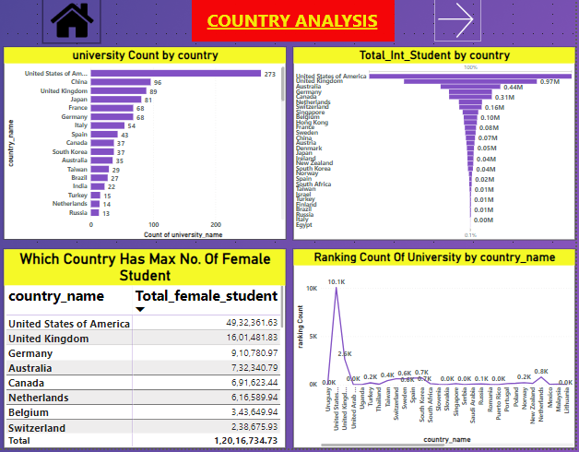

**POWER BI DASHBOARDS**

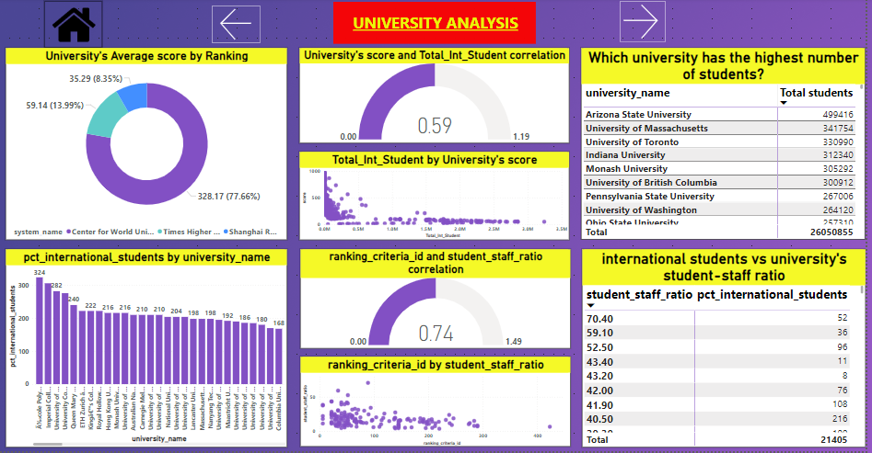

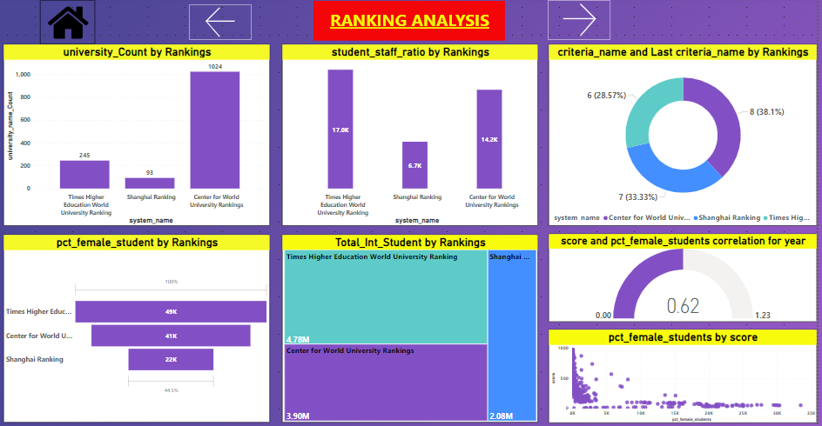

**POWER BI DASHBOARDS**

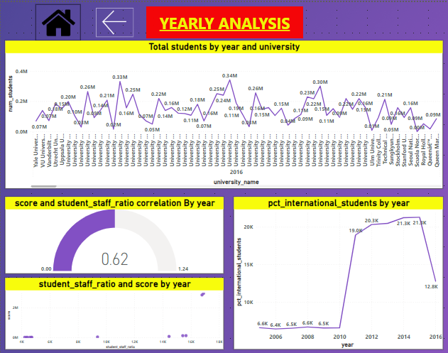

**POWER BI DASHBOARDS**

**CONCLUSION**

**In conclusion, this comprehensive analysis of the university dataset has yielded valuable insights into the global higher education landscape. The dataset, comprising information on countries, universities, ranking systems, criteria, and various metrics, provided a rich foundation for exploration. Key findings include the notable concentration of universities in the United States, underlining its pivotal role in higher education. Additionally, the varying preferences of ranking systems and their distinct evaluation criteria shed light on the complexity of assessing academic institutions on a global scale.**

**The analysis also revealed dynamic trends in university rankings, with fluctuations observed across different countries and ranking systems. This underscores the need for universities and policymakers to remain adaptable in response to changing educational and geopolitical contexts. Furthermore, the correlation between university scores, student-staff ratios, and the enrollment of international students highlighted critical factors influencing academic performance and inclusivity.**

**The dataset also revealed intriguing patterns in student demographics, with notable trends in the enrollment of female and international students. These insights underscore the importance of creating inclusive and supportive learning environments for a diverse student body. Overall, this project has provided valuable perspectives on the global higher education landscape, emphasizing the multifaceted nature of evaluating and understanding universities in an increasingly interconnected world.**